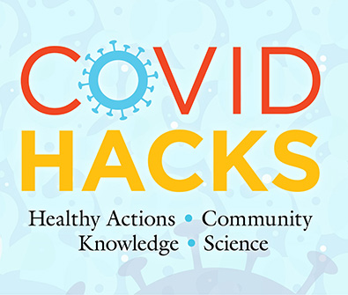
COVID HACKS Field Test

7th Grade
POST-assessment
Word Doc Version

Instructions

- You may use this version of the assessment as it is, or you may copy and paste into a different format of your choosing.

- NO STUDENT NAMES! Remind students of the student ID number they used on the Pre-assessment and instruct them to write it at the top of the front page of this assessment.

- DO NOT discuss the answers to any questions until AFTER the POST-assessment.

- Once finished, SAVE all tests into one document named using your Project ID number as the document name.

- Upload the file with the student tests to the field test project website.



COVID HACKS
7th Grade – Post-assessment

Circle the best answer for each question below.

- How does COVID-19 illness usually spread from one person to another?
- In windy conditions
- In respiratory droplets when we talk or cough
- Mostly on a person’s hands
- Through cups and glasses that are dirty

- What is the purpose of wearing a mask for COVID-19?
- It protects others who are close to you.
- It protects you from others.
- It protects you and others.
- It is not helpful.

- Which of the following is an example of herd immunity to a disease?
- Very few people have been vaccinated.
- A disease spreads rapidly through a group of people without immunity.
- Cattle and other herd animals are affected by a disease.
- A disease cannot spread because many people are immune to it.

- Water droplets can travel farther if they are
- Bigger
- Smaller
- Medium-sized
- Produced by coughs only

- What causes COVID-19 illness?
- Runny nose
- Heredity
- A kind of virus
- A kind of bacteria

- What do vaccines for COVID-19 contain?
- Molecules called RNA or DNA
- Live disease-causing microbes
- Ribosomes and mitochondria
- A combination of dead and live microbes

- How does “social or physical distancing” reduce the spread of COVID-19?
- It keeps you from touching others.
- It reduces contact with respiratory droplets.
- It keeps others out of your personal space.
- It keeps microbes outside.

- How do vaccines prevent diseases?
- They teach the immune system how to defend against a disease.
- They give you the disease so that you are later immune to it.
- They destroy germs that might cause a disease.
- They stop only childhood illness.

- How can you stop the spread of a disease like COVID-19?
- Just wait until it disappears.
- Vaccinate old people.
- Vaccinate young people.
- Get more people vaccinated.

10. What is the purpose of getting a vaccine?
  - Keep you from gaining weight
  - Prevent you from getting sick
  - Treat a disease you already have
  - Help with symptoms of a disease

Do you have any questions remaining about COVID-19, vaccines or viruses in general that have not been answered? Please write them below.

There are no correct answers for the following questions. You are simply being asked your opinion. Indicate your true feelings, not what you think may be an answer that is expected. Circle the number that matches your feelings according to the scale below. It is important that all questions are answered by selecting only one answer.

1 = Strongly disagree, 2 = Disagree, 3 = Neither agree nor disagree, 4 = Agree, 5 = Strongly agree

 | 1  Strongly  disagree | 2  Disagree | 3  Neither  agree nor  disagree | 4  Agree | 5  Strongly  agree
- I know how to reduce my risks of contracting COVID-19. | 1 | 2 | 3 | 4 | 5
- I know where to find trustworthy health information on the Internet. | 1 | 2 | 3 | 4 | 5
- I can explain how vaccines work to friends and family. | 1 | 2 | 3 | 4 | 5
- I can explain how COVID-19 infects people. | 1 | 2 | 3 | 4 | 5
- Learning about science is interesting. | 1 | 2 | 3 | 4 | 5
- I would like to work in a field related to science. | 1 | 2 | 3 | 4 | 5
- I expect to use science when I get out of school. | 1 | 2 | 3 | 4 | 5
- I am curious about the science behind COVID-19. | 1 | 2 | 3 | 4 | 5
- I would like to know more about how scientists make discoveries. | 1 | 2 | 3 | 4 | 5
- I enjoy learning about science topics related to health. | 1 | 2 | 3 | 4 | 5

