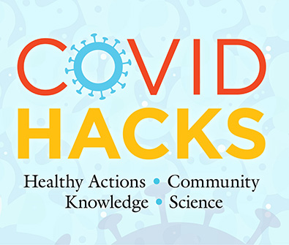
COVID HACKS Field Test

3rd Grade
PRE-assessment
Word Doc Version

Instructions

- You may use this version of the assessment as it is, or you may copy and paste into a different format of your choosing.

- NO STUDENT NAMES! Assign each student an ID number and instruct them to write it at the top of the front page of the assessment. This number can be any number of your choosing.

- DO NOT discuss the answers to any questions until AFTER the POST-assessment. Let your children know they will learn more soon!

- You may read the questions and answer options to the children as needed, but do not coach them.

- Once finished, SAVE all tests into one document named using your Project ID number as the document name.

- Upload the file with the student tests to the field test project website.



COVID HACKS
3rd Grade
Pre-assessment

Circle the best answer for each question below.

- What causes COVID-19 illness?

- Runny nose
- Heredity
- A kind of virus
- A kind of bacteria

- What is the best way to know if you or a family member have
COVID-19?

- Get tested
- Ask your doctor
- Get a physical exam
- See if you get sick

- Which of the following is a common symptom of the coronavirus?

- Increased appetite
- Loss of taste or smell
- Itchy dry skin
- Unusual energy

- What should you do if you think you have symptoms of COVID-19?

- Ask a friend what they think
- Go to school and tell a teacher
- Stay at home and tell an adult
- Don’t worry unless it gets worse

- How does COVID-19 spread?

- In windy conditions
- Only if a person coughs or sneezes on you
- When a person is running
- When a person speaks closely to you

- How does “social or physical distancing” reduce the spread of COVID-19?

- It keeps you from touching others.
- It reduces contact with respiratory droplets.
- It keeps others out of your personal space.
- It keeps microbes outside.

- What is a good distance to stay apart to avoid spreading COVID-19?

- 6 feet
- 10 feet
- 20 feet
- Staying apart isn’t necessary
- Which of the following actions helps prevent catching an infection with COVID-19?

  - Wearing a hat and jacket
  - Sharing school supplies
  - Wearing a face mask
  - Taking antibiotics

- What is the purpose of getting a vaccine?

    - Keep you from gaining weight
    - Prevent you from getting sick
    - Treat a disease you already have
    - Help with symptoms of a disease

What can you do to keep from getting sick with COVID-19?
Write your answer in the box below.

Circle the face that matches your feelings about each of the sentences below.

- I know how to protect myself from COVID-19.
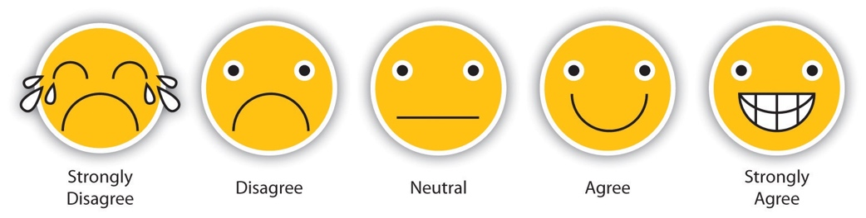

- Learning about science is interesting.

- I know I can do well in science.

- I will need science for my future work.

