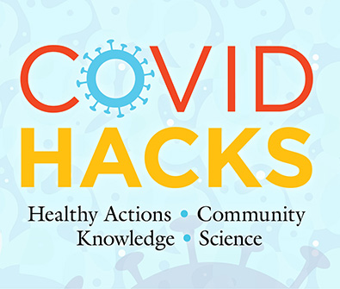
COVID HACKS Field Test

3rd Grade
POST-assessment
Word Doc Version

Instructions

- You may use this version of the assessment as it is, or you may copy and paste into a different format of your choosing.

- NO STUDENT NAMES! Remind students of the student ID number they used on the Pre-assessment and instruct them to write it at the top of the front page of this assessment.

- DO NOT discuss the answers to any questions until AFTER the POST-assessment.

- You may read the questions and answer options to the children as needed, but do not coach them.

- Once finished, SAVE all tests into one document named using YOUR Project ID number as the document name.

- Upload the file with the student tests to the field test project website.



COVID HACKS
3rd Grade
Post-assessment

Circle the best answer for each question below.

- What causes COVID-19 illness?

- Runny nose
- Heredity
- A kind of virus
- A kind of bacteria

- What is the best way to know if you or a family member have
COVID-19?

- Get tested
- Ask your doctor
- Get a physical exam
- See if you get sick

- Which of the following is a common symptom of the coronavirus?

- Increased appetite
- Loss of taste or smell
- Itchy dry skin
- Unusual energy

- What should you do if you think you have symptoms of COVID-19?

- Ask a friend what they think
- Go to school and tell a teacher
- Stay at home and tell an adult
- Don’t worry unless it gets worse

- How does COVID-19 spread?

- In windy conditions
- Only if a person coughs or sneezes on you
- When a person is running
- When a person speaks closely to you

- How does “social or physical distancing” reduce the spread of COVID-19?

- It keeps you from touching others.
- It reduces contact with respiratory droplets.
- It keeps others out of your personal space.
- It keeps microbes outside.

- What is a good distance to stay apart to avoid spreading COVID-19?

- 6 feet
- 10 feet
- 20 feet
- Staying apart isn’t necessary
- Which of the following actions helps prevent catching an infection with COVID-19?

  - Wearing a hat and jacket
  - Sharing school supplies
  - Wearing a face mask
  - Taking antibiotics

- What is the purpose of getting a vaccine?

    - Keep you from gaining weight
    - Prevent you from getting sick
    - Treat a disease you already have
    - Help with symptoms of a disease

What are you still wondering about COVID-19?
Write your answer in the box below.

Circle the face that matches your feelings about each of the sentences below.

- I know how to protect myself from COVID-19.
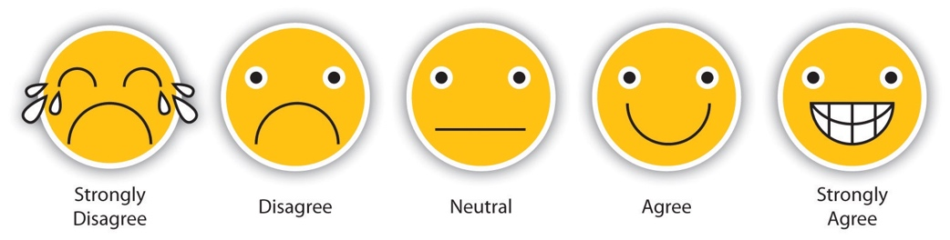

- Learning about science is interesting.

- I know I can do well in science.

- I will need science for my future work.

