
COVID HACKS Field Test
Shipping Form and Stipend Invoice

Thank you again for participating in our field test!

- Please complete BOTH forms in this document.

- Once complete, SAVE the document as a PDF or Word doc and RENAME to “Stipend” followed by your Project ID.
(e.g., if your project ID is 10001012 you would name this document
“Stipend 10001012”)

- Finally, UPLOAD your forms to the secure BCM Box Folder
(Link below and on the project website):
https://bcm.app.box.com/f/943dce1a86204c3c9dcae86bdbaceb0b

If you have any questions, please feel free to contact us:

edoutreach@bcm.edu

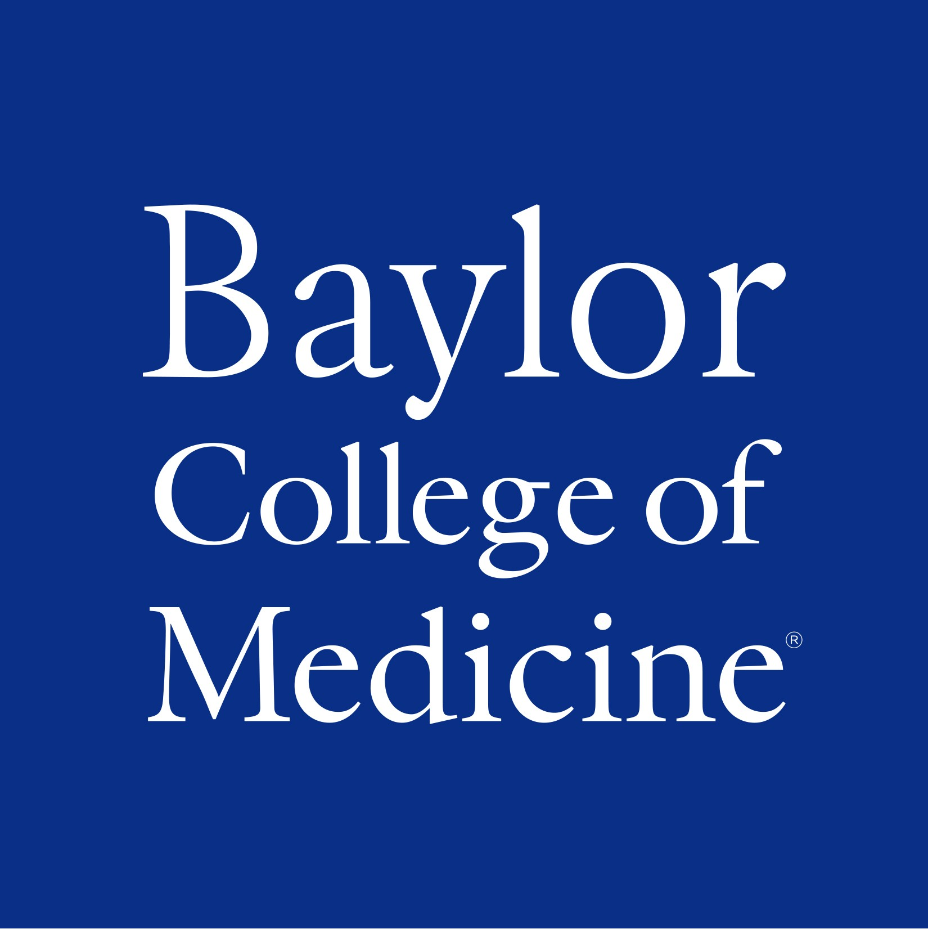
COVID HACKS
Materials Shipping Form

Please select your grade band below:

Elementary School (3rd grade)
Middle School (7th grade)
High School (9th or 10th Biology)

Please indicate the approximate number of students who will complete the project assessments in each format (you may select more than one).

NOTE: even if all students will be virtual, please provide your best guess. This will let us know about how many assessments to look out for.

FORMAT | # of STUDENTS
Paper Scantron Forms  (this is the number of paper assessments you will receive.) | 0
Digital Word or PDF Forms | 0
Other Digital Format (e.g., Nearpod)  (Please note the format you plan to use.) | 0
SurveyMonkey  (We will set up SurveyMonkey links for you to send to your class.) | 0

Please provide the shipping address where we should send your paper assessments and any student materials required for your grade band.

First & Last Name:
Shipping Address:
City, State, Zip:

STIPEND INVOICE

Field Test for COVID HACKS
Spring 2021

PROJECT ID #:
(First 4 digits of driver license + 2 digit birth month + 2 digit birth day)

Bill to Baylor College of Medicine
Center for Educational Outreach
One Baylor Plaza
Houston, Texas 77030

Phone (713) 798-8200
Fax (713) 798-8201

TOTAL DUE: $250.00

Payable to:

Name:
Address:
City: | State: | Zip:
School Name:
Home Phone:
Phone:
E-mail:
Social Security Number:
(required by Baylor accounting for payment)
Signature:
Date:

